Student Name: Aditya Verma UID: 24BAI70937
Branch: AIT-CSE- AIML Section/Group: 24AIT_KRG-G2
Semester: 4
Subject Name: DBMS

WORKSHEET 4
AIM: To understand and apply SQL conditional logic using the MOD (%) operator to classify numerical data. The experiment focuses on analyzing employee salary values and determining whether they are odd or even, thereby improving data analysis and decision-making capabilities using SQL queries.

S/W Requirement: • Database Management System: PostgreSQL / Oracle Database Express Edition
• Database Administration Tool: pgAdmin

OBJECTIVES:
• To understand the concept of conditional logic in SQL queries.
• To apply the MOD (%) operator to determine odd and even values.
• To analyze employee salary data using SQL conditions.
• To improve query writing skills for data filtering and classification.

PROBLEM STATEMENT:
Develop and execute SQL queries that demonstrate conditional logic using the MOD (%) operator. The program should analyze employee salary values and categorize them as odd or even using SQL queries.

1. PROBLEM STATEMENT – DISPLAY ALL EMPLOYEE DETAILS
Write an SQL query to create an employee table and display all employee records.
PROGRAM:

CREATE TABLE employee (
emp_id NUMBER,
emp_name VARCHAR2(50),
salary NUMBER
);

INSERT INTO employee VALUES (101, 'Rahul', 25000);
INSERT INTO employee VALUES (102, 'Amit', 32001);
INSERT INTO employee VALUES (103, 'Neha', 45000);
INSERT INTO employee VALUES (104, 'Priya', 27555);
INSERT INTO employee VALUES (105, 'Rohan', 30000);

SELECT * FROM employee;

2. PROBLEM STATEMENT – DISPLAY EMPLOYEES WITH EVEN SALARY
Write an SQL query to display employees whose salary values are even numbers using the MOD operator.
PROGRAM:
DECLARE
SELECT emp_id, emp_name, salary
FROM employee
WHERE MOD(salary, 2) = 0;

3. PROBLEM STATEMENT – DISPLAY EMPLOYEES WITH ODD SALARY
Write an SQL query to display employees whose salary values are odd numbers using the MOD operator.
PROGRAM:
SELECT emp_id, emp_name, salary
FROM employee
WHERE MOD(salary, 2) = 1;

4. PROBLEM STATEMENT – CLASSIFY SALARY AS ODD OR EVEN
Write an SQL query to classify each employee salary as Odd or Even using a CASE statement.
PROGRAM:
SELECT emp_id,
emp_name,
salary,
CASE
WHEN MOD(salary,2)=0 THEN 'Even Salary'
ELSE 'Odd Salary'
END AS salary_type
FROM employee;

LEARNING OUTCOMES:
- Understood how conditional logic can be applied in SQL queries.
- Learned the use of the MOD (%) operator to determine odd and even values.
- Gained knowledge about filtering records using conditional expressions.
- Implemented CASE statements for classification of data.
- Improved SQL query writing and logical analysis skills.

OUTPUT :
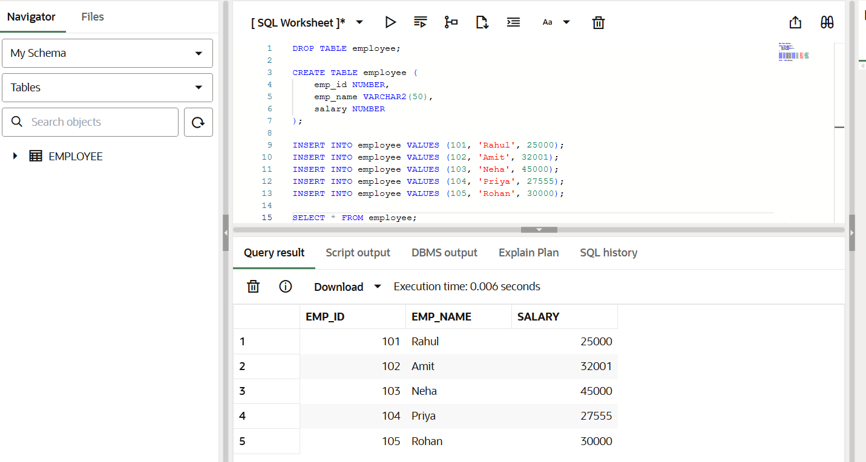
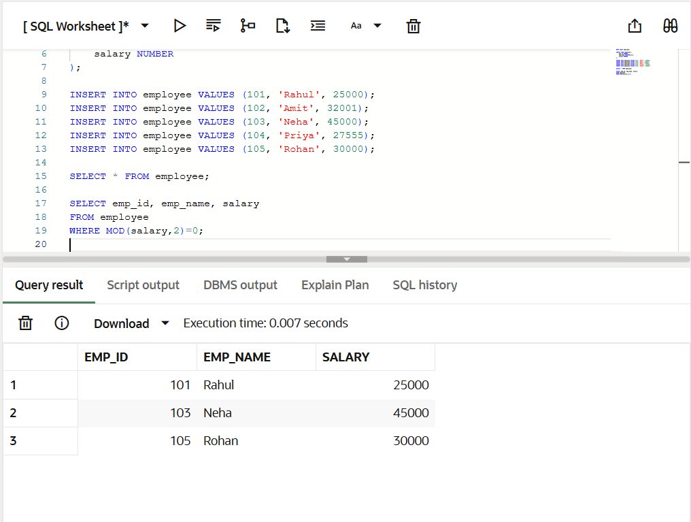
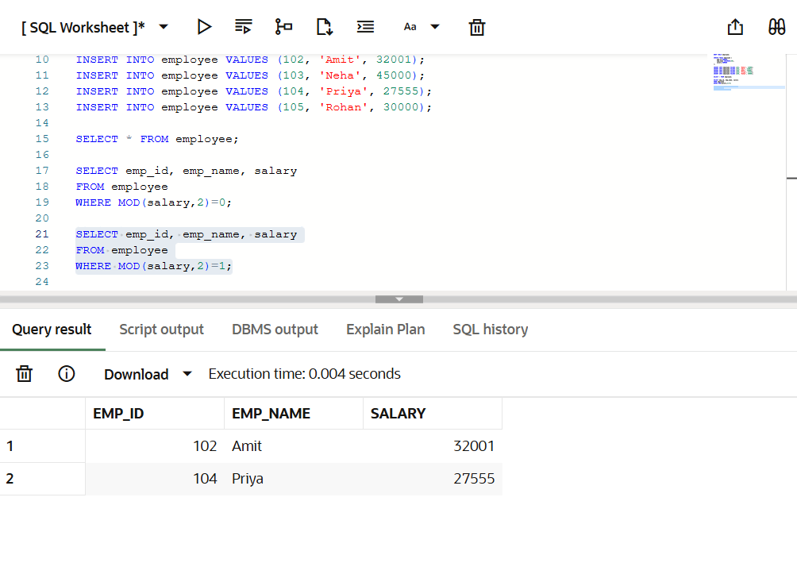

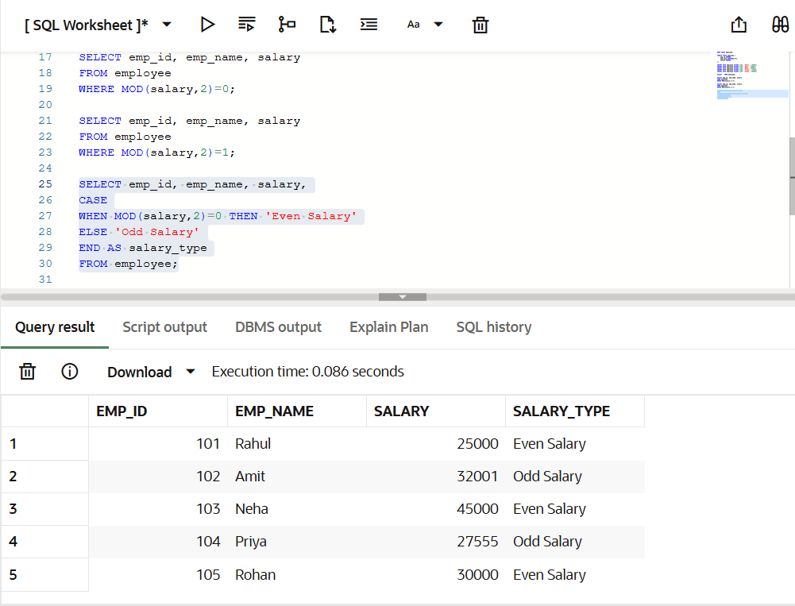

CONCLUSION:
This experiment helped in understanding the use of conditional logic in SQL queries using the MOD operator. By analyzing employee salary data and classifying it as odd or even, the experiment demonstrated how SQL can be used effectively for data analysis and logical decision-making.

